*TrailEthiopian Tours &Travel*



# [www.trailethiotour.com](http://www.trailethiotour.com/)

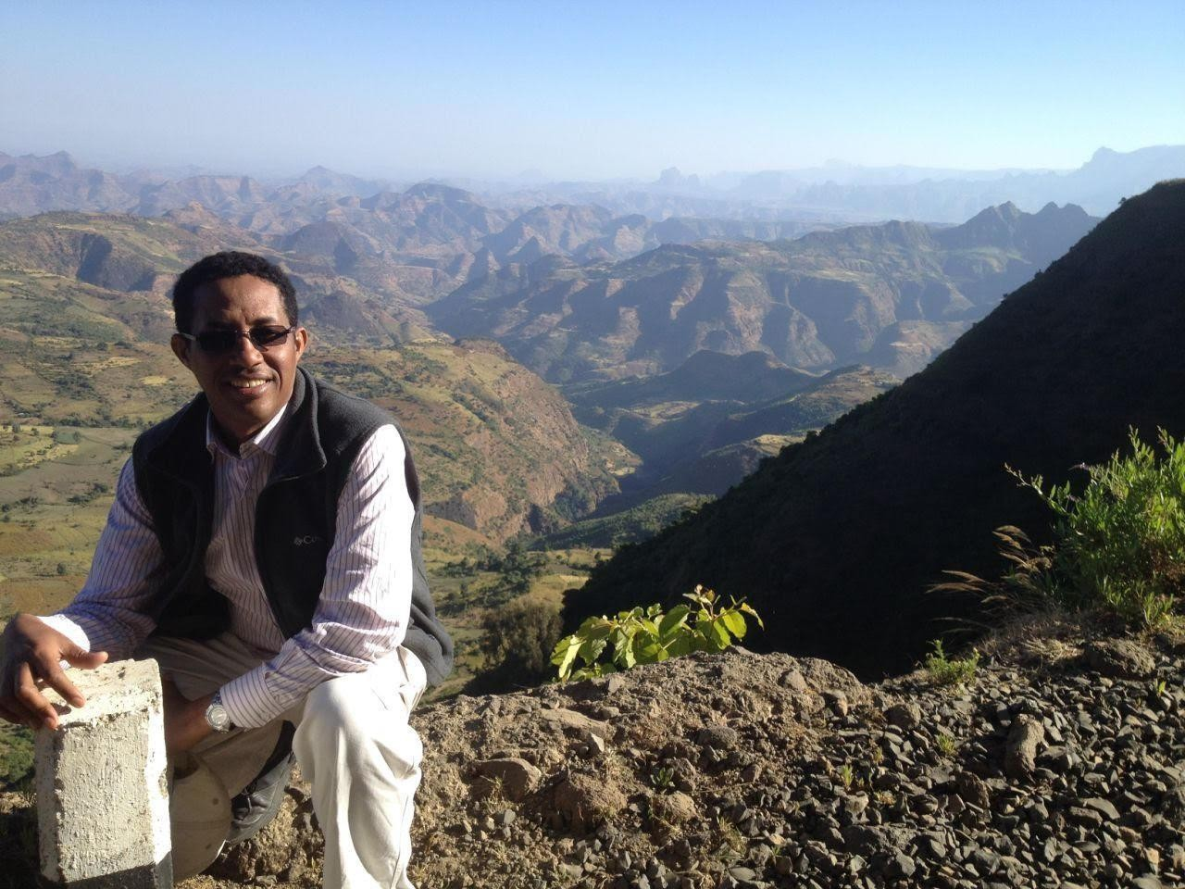

TESFAYE MIDEKSA

Dear Mr./ Madam,

Thank you very much again for reaching out to me and your request to visit Ethiopia.

Following your request, I have put a tour package together for you that suitable with your time and interest.

Below is the tour program along with carefully quoted price.

# **TYPE OF TOUR**

***NORTH CLASSIC ROUTE:Tour Program of the Northern historical sites and the Semien Mountains (7 Nights and 8 Days)***

# **SCHEDULE**

**Day One**

Arrival at Bole international airport and be meet with me and transfer to your hotel, after some refreshment and rest, Addis Ababa city tour that includes, National Museum exhibiting historical, Archeological, pale-ontological (Lucy or Dinqinesh) and many other findings. The Trinity cathedral famous for its unusual Ethiopian church architecture, Ethnological museum, driving through the main street & avenues, Churchill road and also Addis gives you time for a little exploring into this fascinating city and perhaps a little souvenir shopping –gold, silver, jewelers, leatherwork, materials, art works to name but a few. O/N Debre Damo hotel

**Day Two**

Morning flight to Bahirdar and be transferred to your hotel. In the morning, drive 35 km to the Blue Nile falls and to the Portuguese Bridge, Bahirdar town: the local market, and in the afternoon, boat trip to the medieval monasteries of the Zeghie peninsula and to the out let of the Blue Nile River. O/N at Blue Nile resort.

**Day Three**

Morning drive to Gondar through the spectacular Tara Gedam Mountain ranges. Enroute, you will see the 16th c. castle of Emperor SarsaDengel and drive further to Gondar.After lunch, you will see the church of DebreBirhan Selassie which is painstakingly decorated by a local monk and historical sites such as the royal palace of emperor Fasiledes, the Qusquam enclosure, the bath palace of emperor Fasiledes. O/N Goha hotel

**Day Four**

Day drive to the marvelous Semien Mountains. You will have a short stop at the breath taking scenery of Kossoye before reaching Debark. At Debark (which is 100 km away from Gondar), you will collect the entrance fees, a park guide and park ranger to drive further into the inner part of the park to the extent of Sankaber along the spectacular sceneries,

here you will enjoy the views and the herds of unique Gelada Baboons then drive back to Gondar. O/N Goha

**Day Five**

Be transferred to Gondar airport for your flight to Axum. You will be transferred to your hotel. Then, you will start the sightseeing of historical sites in Axum such as the stele park, tombstones of king Kaleb, King GebreMeskal and king Bazen and the churches of Mary Zion, the archaeological museum and the bath and the palace of Queen Sheba O/N at YaredZema hotel

**Day Six**

After a relaxing morning, transfer to Axum Airport to leave for Lalibela and be transferred to your hotel then, Visit of Lalibela brings you to yet more wonder – the rock-hewn churches.

The churches of Lalibela are among the most extraordinary architectural creations of human civilization. Each church is sculpted, both inside and out, directly from the living bedrock of the earth.

The probable method of construction was for craftsman to first sink trenches directly into the stone, then to slowly chisel away excess Stone to reveal exterior and interior spaces.

Narrow, labyrinthine tunnels connect several of the churches, and the walls of the trenches and courtyards contain cavities and chambers filled with mummies of pious monks and pilgrims. The churches are still used for worship today and many are filled with richly painted biblical murals and also you will have a visit of the second group of churches(consisting of 4 churches) and the third group consisting only one but the most beautiful and monolithic cruciform church of St. George. It is said to be the symbolization of the Noah’s. O/N Tukul Village hotel

**Day Seven**

This morning there will be optional excursion tour to Neakutoleab and in the Afternoon, you will have a visit of the second group of churches

(consisting of 4 churches) and the third group consisting only one but the most beautiful and monolithic cruciform church of St. George. It is said to be the symbolization of the Noah's Arc. O/N Tukul Village hotel

**Day Eight**

Day drive to Konbolcha along the since route through eye catchy mountain ranges, after you will be drop off at your hotel, it will be the end of the program. O/N at Sunny Side hotel in Konbolcha

# **PRICE**

The price for the above Itinerary will be $**xxxx USD** per person for three paying pax. The above price includes the following services:

1. Full board hotel accommodation on Triple bed occupancy basis and on three meals basis per day
2. Independent use of a comprehensively insured 4WD Toyota Land cruiser to and from Bahie Dar- Gondar - Simien Mountain and back to Gondar and from surface drive from Lalibela to Konbolcha with driver perdiem, fuel and free mileage
3. All entrance payment throughout the program at visited areas.
4. All tour and transfer at all places as well.
5. Use of professional guiding services at each destination
6. Boat trip to Medieval Monasteries on Lake Tana monastery
7. Payment for park guide and ranger at Semien National park
8. You will be provided a bottled mineral water every day
9. Hotel accommodation in Addis and city tour of Addis including all transfers
10. All government tax

The above price**EXCLUDES** the following:

1. Domestic flight fare for the sector of ADD-BJR//GDQ- AXUM- LLI- -ADD will be $ XXX **USD** per person
2. Visit of place not mentioned in the program
3. International flight fare and Visa fees
4. All personal nature expenses such as Video camera & photographing fees, tips and the like.

**NOTE:** You will be invited cultural dinner at local restaurant where you will taste traditional food, and traditional drinks such as honey wine that will be accompanied with traditional folklore dance at the end of your tour.

Be assured that you will be happy with the services and your tour will be life time memorable.

Awaiting your reply with pleasure.

Thank you and best regards,

Tesfaye Mideksa

Tour Guide Specialist& Owner Trail Ethiopian Tour & Travel [www.trailethiotour.com](http://www.trailethiotour.com/)

Tel: 251-9-11-60-38-67/251912955475